

INTERNAL COMBUSTION ENGINES 1

TERM PROJECT

ENGINE CYCLES PROGRAMME

Name: Ufuk Mamikoglu

Number: 150415055

There are three air-standard cycles:

• constant volume ‘combustion’ (Otto),

• constant pressure ‘combustion’ (Diesel) and

• dual ‘combustion’ – this is a combination of constant volume and constant pressure combustion, and results in a slightly more realistic cycle.

These are the heat engine equivalent of the reciprocating engine and different from the actual engine cycle because:

• the cycle is a closed one with heat transfer;

• the working fluid does not change composition;

• the energy addition obeys closely defined rules, e.g. constant volume energy addition;

• the rates of heat release (energy addition) are unrealistic;

• indicated work outputs are evaluated.

The effect of two differences between ideal and real cycles :

1. frictional losses and

2. the finite rate of heat release.

OTTO CYCLE

The Otto cycle is an air-standard cycle which approximates the processes in petrol or diesel engines. It is based on constant volume heat addition (combustion) and heat rejection processes, and isentropic compression and expansion. The diagram is where it is superimposed on an actual p–V diagram for a diesel engine.

The actual p–V diagram for an engine has rounded corners because of the processes of combustion take place at a finite rate. The Otto cycle has sharp corners because the ‘combustion’ is switched on and off instantaneously. It can be that the area of the Otto cycle is larger than that of the actual cycle, and this has to be taken into account when analyzing engine cycles – the actual engine cycle will always produce less work output than the Otto cycle.

A typical engine ‘cycle’ is defined in Figure 1. It consists of a compression stroke (Figure 1(a)), followed by a period of combustion close to top dead centre (tdc) (Figure 1(b)) and then by expansion (Figure 1 (c)). These two strokes form the power producing processes, but afterwards the products of combustion have to be replaced by fresh air. This is symbolized in Figure 1 (d), where the exhaust valve is open at the beginning of the exhaust stroke. In a four-stroke engine the piston executes two complete revolutions of the crankshaft, and uses two strokes while the gas is pushed out by the piston on the up stroke, and then the intake valve is opened to enable air to be induced. In a two-stroke engine the intake and exhaust strokes occur at the end and the beginning of the expansion and compression strokes, respectively. These processes are called the gas exchange processes, and are one of the main reasons why real engines are not heat engines. The other reason is the combustion process, when the air is used to burn the fuel. This process of combustion means that the fluid in the engine cannot undergo a cycle.

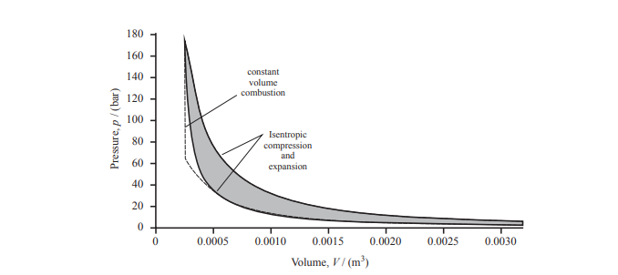

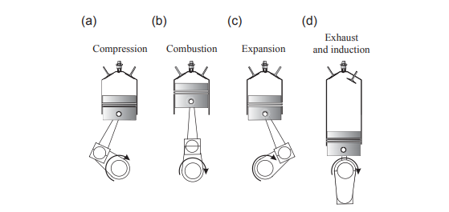

Figure 1

The Otto, Diesel and dual-combustion cycles are air-standard cycles that approximate the processes in a real engine. They can be achieved in the following way:

• The combustion process is replaced by a heat transfer process in which an amount of energy equivalent to the energy released by combustion is added to the air;

• The gas exchange process is replaced by a heat transfer process to a cold reservoir, so that the hot gases after expansion are returned to the state of the air after induction.

The resulting air-standard cycle is defined in Figure 2.

The basic Otto cycle is made up of four processes:

• Isentropic compression;

• Constant volume heat addition;

• Isentropic expansion and

• Constant volume heat rejection.

These can be depicted on T–s and p–V diagrams as shown in Figure 3.

Since all the processes in Figure 3 are reversible, the areas of the diagrams (a and b) are equal, and depict the work done in the cycle. The work done is

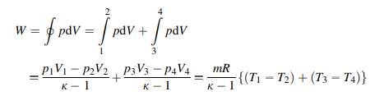

The energy added to the cycle is that added at constant volume between 2 and 3, and is given by:



Hence the thermal efficiency is:

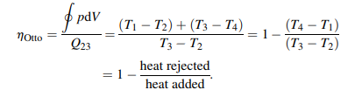

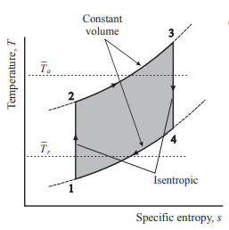

Figure 3.1

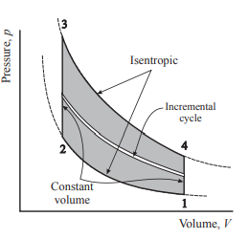

Figure 3.2

DIESEL CYCLE

The Diesel cycle also applies to reciprocating engines, and is similar to the Otto cycle except that the heat is applied at constant pressure rather than constant volume. This removes the limitation of infinite rates of combustion implied by the Otto cycle, but still results in an unrealistic combustion pattern. The Diesel cycle is shown in Figure 4:

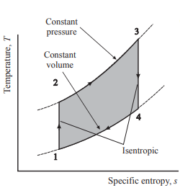 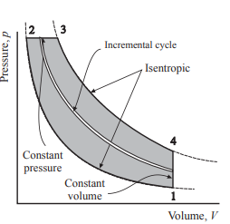

Figure 4.1Figure 4.2

The work done in a Diesel cycle is

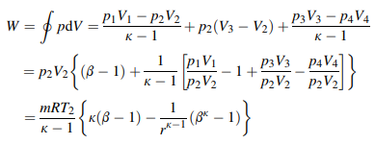

where b defines the size of the constant pressure heat addition region, ß=/. The effect of the

constant pressure heat addition region is to reduce the expansion ratio of the cycle, = / = r/ß. This has a large effect on the efficiency of the cycle.

The heat addition is



The efficiency of the cycle is

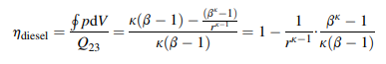

This efficiency is less than that of the Otto cycle because the term 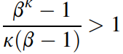

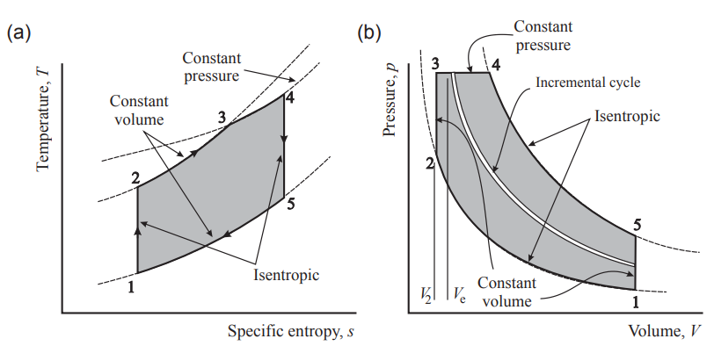

Figure 5

DUAL CYCLE

The dual-combustion cycle is shown in Figure 5. The cycle gets its name because a proportion of the ‘combustion’ (heat addition) takes place at constant volume, from 2 to 3, and then the remainder occurs at constant pressure, from 3 to 4. This cycle is the most representative of real engine cycles, in which the initial combustion takes place rapidly, and then slows down later in the process (although the dual-combustion cycle requires the heat release to increase as the volume increases). It can be shown (this is left to the reader) that the efficiency of a dual-combustion cycle is

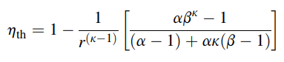

where a , the pressure ratio caused by constant volume combustion.

PROGRAMME INTERPRETATIONS

We created a graphical user interface to calculate certain output values for different type of engines with different air intake types and with different properties. Our programme asks the user to select engine type, stroke type. After that, it asks user to give inputs for calculations such as the engine volume, speed, rod lenght, ambient temperature, pressure etc.

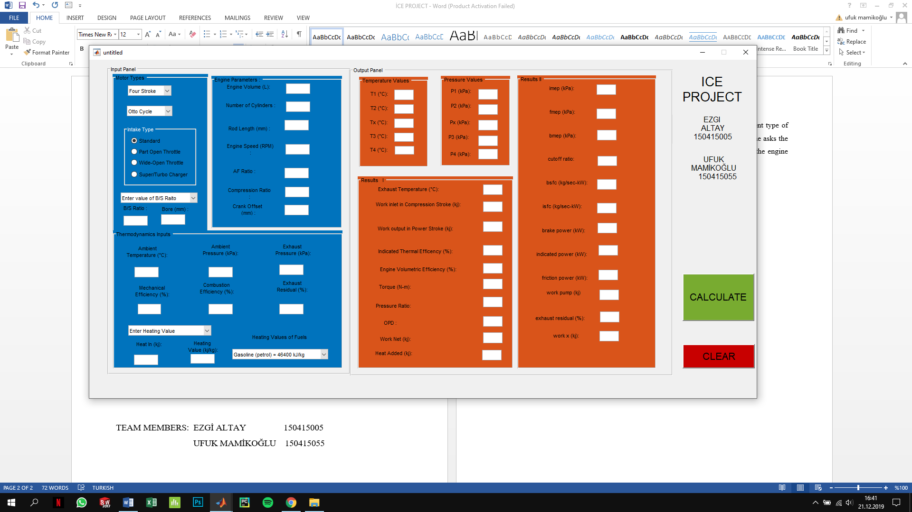

Figure 1: Input Panel

After giving the input values and selecting some properties, the results are shown in the result panel.



Figure 2: Result Panel

OTTO CYCLE EXAMPLE

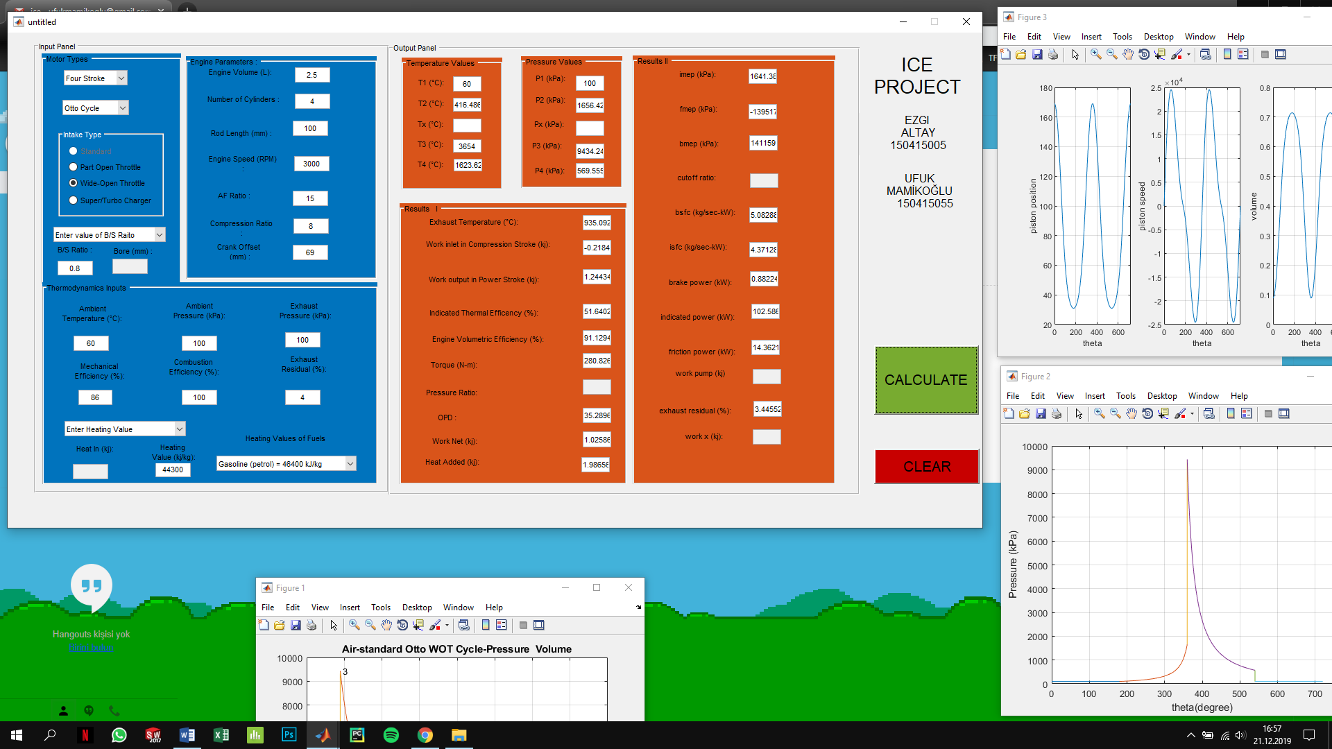

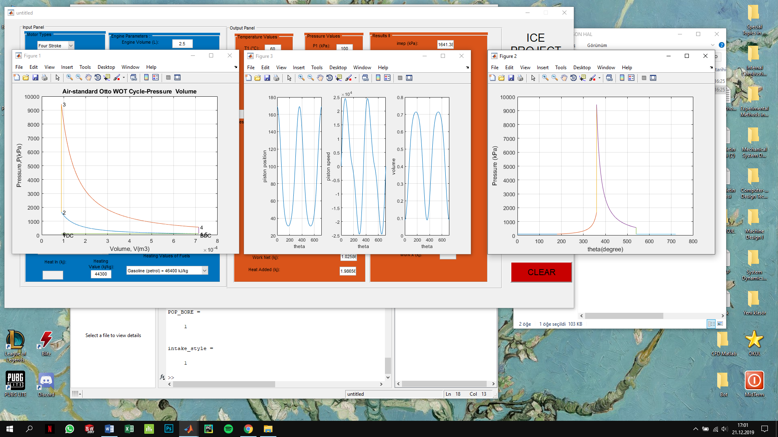





DIESEL CYCLE EXAMPLE

